  ICT DEPARTMENT WEBSITE PROJECT | INTERNET PROGRAMMING II

MUT ICT DEPARTMENT SMART WEBSITE

Full-Stack Web Application Documentation

Internet Programming 2 (ITPR300/ITNP300) – Assessment 2

Submission Date: 13 May 2026
Lecturer: MR X PIYOSE
External Moderator: MR PK RAMDEYAL
Gumbi MP | 22330742
Mnyawe S | 22425322
Rhongwana B | 22422182
Cebekhulu S | 22322695
Ngcobo AM | 22433852

TABLE OF CONTENTS
Contents
Full-Stack Web Application Documentation 1
Internet Programming 2 (ITPR300/ITNP300) – Assessment 2 1
1. PROBLEM STATEMENT & WEBSITE ANALYSIS 1
1.1 Original ICT Department Website Weaknesses 1
1.2 Proposed Improvements 2
2. UXD REDESIGN & FRONTEND STRUCTURE 2
2.1 User-Centred Design Principles Applied 2
2.2 Colour Scheme 3
2.3 Page Structure 3
2.4 Responsive Design Implementation 4
2.5 Frontend Technologies Used 4
3. FRONTEND INTERACTIVITY (JAVASCRIPT) 4
3.1 Interactive Features Implemented 4
3.2 Code Example: Form Validation 6
3.3 Code Example: Countdown Timer 6
4. BACKEND DEVELOPMENT (NODE.JS + EXPRESS) 7
4.1 Server Setup 7
4.2 API Endpoints Summary 8
4.3 HTTP Methods Explained 9
4.4 Request-Response Flow Example 10
5. DATABASE DESIGN & INTEGRATION 11
5.1 Database: MySQL 11
5.2 Entity Relationship Diagram 12
5.3 Table Structures 12
5.4 CRUD Operations Implementation 14
5.5 Database Connection Code 14
5.6 Sample Data (Pre-populated) 15
6. MIDDLEWARE IMPLEMENTATION 15
6.1 Types of Middleware Used 15
6.2 Custom Logger Middleware 15
6.3 Why Middleware is Important 16
6.4 Middleware Execution Flow Diagram 17
7. AI INTEGRATION & SMART FEATURE 17
7.1 Smart Feature: MUT ICT AI Assistant (Chatbot) 17
7.2 Chatbot Features 19
7.3 Knowledge Base Structure 19
7.4 Chatbot Response Logic 20
7.5 Chatbot Interface 21
7.6 Chatbot User Flow 21
7.7 Benefits of AI Assistant for ICT Department 22
8. FULL SYSTEM INTEGRATION 22
8.1 System Architecture Diagram 22
8.2 Data Flow Example: Submitting an Enquiry 24
8.3 Testing Summary 24
9. GITHUB REPOSITORY & CODE QUALITY 25
9.1 Repository Structure 25
9.2 Code Quality Standards 26
9.3 README.md Content 26
10. GROUP MEMBER CONTRIBUTIONS 28
Evidence of Technical Contribution (All Members) 28
11. INSTALLATION & RUNNING INSTRUCTIONS 28
Prerequisites 28
Step-by-Step Setup 29

1. PROBLEM STATEMENT & WEBSITE ANALYSIS

1.1 Original ICT Department Website Weaknesses

After analysing the current MUT ICT Department website, the following weaknesses were identified:

Weakness | Description | Impact
Static Content | Website displays fixed information only | No user interaction, cannot submit enquiries
Poor Navigation | Menu structure is confusing | Users struggle to find information
No User Accounts | No student/guest login system | Cannot personalise content
No Search Feature | Users cannot search for content | Wasted time finding information
No Database | All data is hardcoded | Cannot store enquiries or registrations
Poor Mobile Experience | Layout breaks on phones | Frustrating experience on mobile devices
No Feedback System | Forms don't show success/error messages | Users don't know if submissions worked
No AI Assistance | No chatbot or smart help | Users cannot get instant answers

Old website screenshots
https://drive.google.com/drive/folders/17d-S8WW0PYqDqVumKcu50vhrjXl79bUA?usp=sharing

1.2 Proposed Improvements
Improvement | Implementation
Dynamic Content | Database-driven pages with CRUD operations
Improved Navigation | Clear menu with active page indicators
User Authentication | Student + Guest login/registration system
Smart Search | Instant search with results dropdown
Database Integration | MySQL stores enquiries, events, announcements
Responsive Design | Tailwind CSS + Flexbox for all screen sizes
Form Validation | Real-time client-side validation with feedback
AI Chatbot | Intelligent assistant answering ICT queries

2. UXD REDESIGN & FRONTEND STRUCTURE

2.1 User-Centred Design Principles Applied
UXD Principle | How It Was Implemented
Consistency | Same header, footer, colour scheme across all pages
Accessibility | High contrast colours, alt text for images, semantic HTML
Responsiveness | Mobile menu, flexible grid layouts, breakpoints at 768px
Feedback Messages | Toast notifications for form submissions, error/success alerts
Visual Hierarchy | Bold headings, colour-coded sections, card-based layout
Navigation Clarity | Active page indicators, breadcrumb trail, clear CTAs

2.2 Colour Scheme

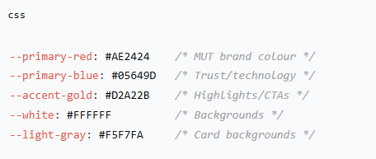

2.3 Page Structure
Page | Purpose | Key Features
Home | Landing page | Hero section, statistics, testimonials, events countdown
Why ICT | Career information | Benefits, opportunities, industry demand
Specializations | Stream options | Software Dev vs Communication Networks
Programs | Qualification details | Expandable program cards with filters
Admission | Application info | Requirements, process, CAO link
Staff | Lecturer profiles | Contact details, office hours, qualifications
Resources | Study materials | Document viewer, downloads, timetable modal
Contact | Enquiry form | Validation, email collection, subject selection

2.4 Responsive Design Implementation

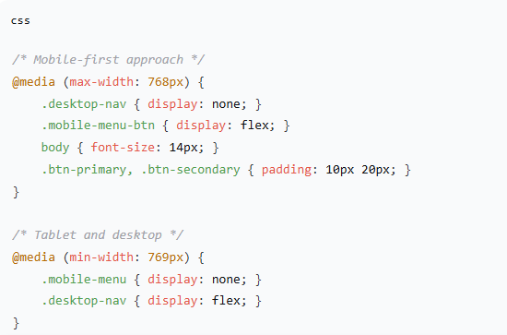

2.5 Frontend Technologies Used
Technology | Purpose
HTML5 | Page structure and semantics
Tailwind CSS | Utility-first responsive styling
Custom CSS | Specific animations and overrides
Google Fonts | Montserrat (headings) + Open Sans (body)
Font Awesome | Icons for visual enhancement

3. FRONTEND INTERACTIVITY (JAVASCRIPT)

3.1 Interactive Features Implemented
Feature | Location | Description
Form Validation | Contact page, Login page | Real-time validation with error messages
Modal Windows | Apply Now, Resources, Events | Pop-up modals for focused interactions
Dynamic Search | Header search bar | Instant results dropdown, page navigation
Content Toggling | Programs page | Expandable program details
Tab Switching | Resources page | Study Materials, Schedule, Guidelines tabs
Countdown Timers | Home page events | Dynamic countdown to hackathon, bootcamp, competition
Filtering | Programs page | Filter by Software/Networks streams
Mobile Menu | All pages | Hamburger menu for mobile devices
Cookie Banner | All pages | GDPR-style consent with localStorage
Document Preview | Resources page | PDF and PPTX viewer in modal

3.2 Code Example: Form Validation
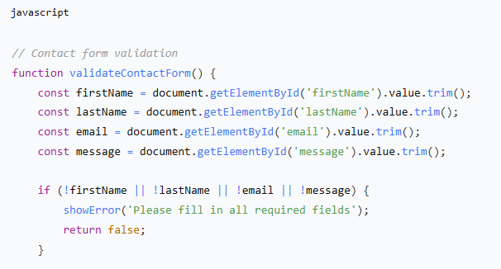
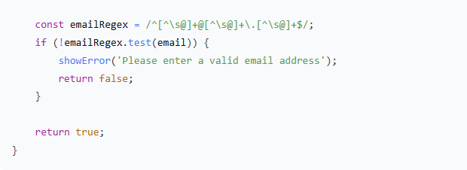

3.3 Code Example: Countdown Timer

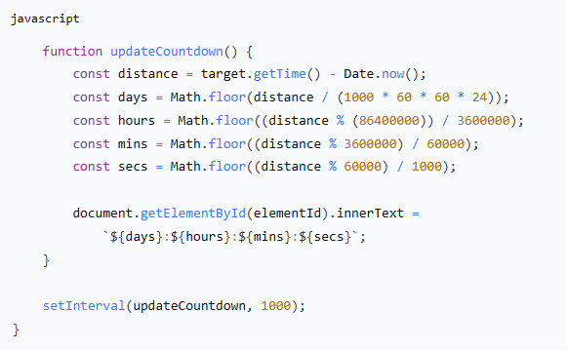

4. BACKEND DEVELOPMENT (NODE.JS + EXPRESS)

4.1 Server Setup
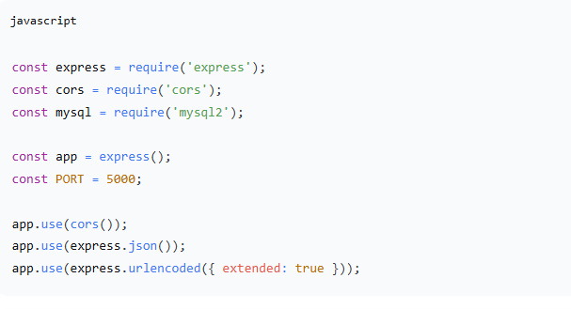
The backend server starting and handling requests
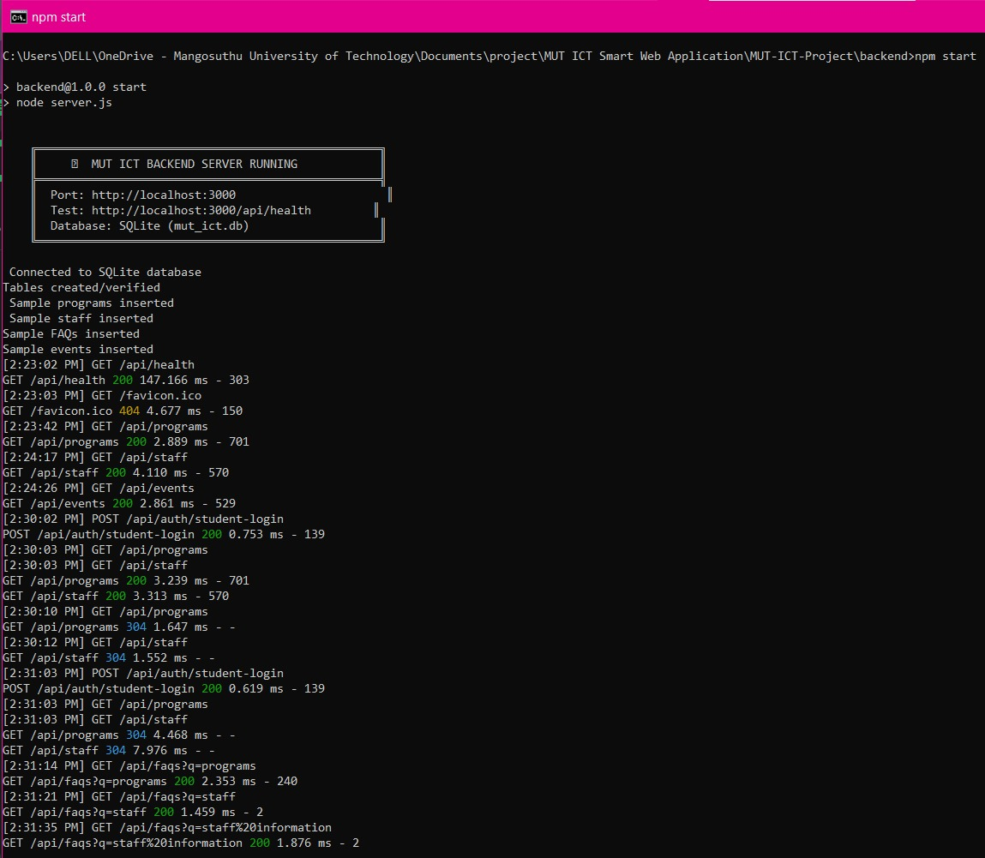
Figure 1: Backend server running on localhost:3000 -showing successful SQLite database connection, table creation and sample data insertion.

The terminal output from testing the health check endpoint
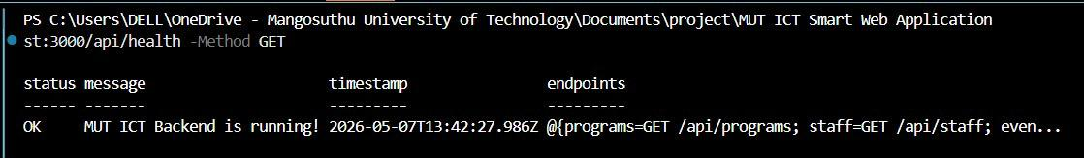
Figure 2: Terminal output of the `GET /api/health` endpoint request, showing backend server status as "OK", a timestamp of the request, and a list of available API endpoints for the MUT ICT Smart Web Application.

JSON response from the health check endpoint
Figure 3: JSON response from GET /api/health confirming the MUT ICT backend server is running and listing available endpoints.

The JSON response from the events endpoint
Figure 4: JSON response from the `/api/events` endpoint showing upcoming MUT ICT events, including event title, description, date, time, and location.

JSON response from the FAQs endpoint
Figure 5: JSON response from the `/api/faqs` endpoint showing an admission-related frequently asked question and its corresponding answer, including category and keywords for search functionality.

4.2 API Endpoints Summary
Method | Endpoint | Purpose | CRUD Operation
GET | /api/health | Server status check | -
GET | /api/notes | Fetch all notes | Read
GET | /api/notes/download/:filename | Download specific note | Read
POST | /api/login/student | Student authentication | -
POST | /api/login/guest | Guest authentication | -
POST | /api/register/guest | Create guest account | Create
POST | /api/enquiries | Submit enquiry | Create
GET | /api/enquiries | Get all enquiries | Read
GET | /api/enquiries/:id | Get single enquiry | Read
DELETE | /api/enquiries/:id | Delete enquiry | Delete
GET | /api/events | Get all events | Read
GET | /api/events/:id | Get single event | Read
POST | /api/events | Create event | Create
PUT | /api/events/:id | Update event | Update
DELETE | /api/events/:id | Delete event | Delete
GET | /api/announcements | Get announcements | Read
POST | /api/contact | Contact form submission | Create

JSON response from the programs endpoint
Figure 6: JSON response from the `/api/programs` endpoint listing academic IT qualifications offered by MUT ICT, including program title, type, duration, NQF level, and description.

JSON response from the staff endpoint
Figure 7: JSON response from the endpoint displaying MUT ICT staff profiles, including names, positions, contact details, office locations, and areas of specialization.

4.3 HTTP Methods Explained
Method | Usage in System | Example
GET | Retrieve data | GET /api/events – fetch all events
POST | Create new data | POST /api/enquiries – submit enquiry
PUT | Full update | PUT /api/events/:id – update event details
DELETE | Remove data | DELETE /api/enquiries/:id – delete enquiry

4.4 Request-Response Flow Example

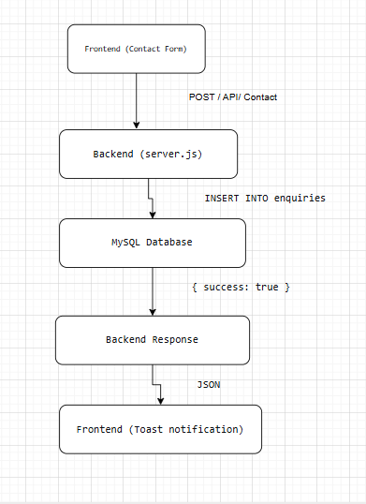

Server logout output
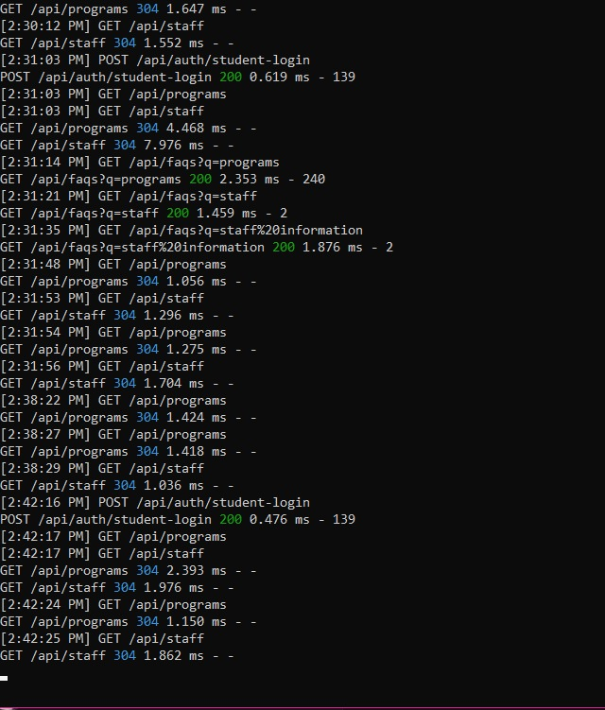
Figure 8: Live API route activity log -demonstrating GET/api/programs, GET/api/staff, POST/api/auth/student-login and GET/api/faqs responding successfully.

5. DATABASE DESIGN & INTEGRATION

5.1 Database: MySQL
Database Information

Property | Value
Database Name | mut_ict_db
Database Type | MySQL
Port | 3307 (XAMPP default) or 3306
Tables Created | 4 (enquiries, guest_users, events, announcements)

5.2 Entity Relationship Diagram
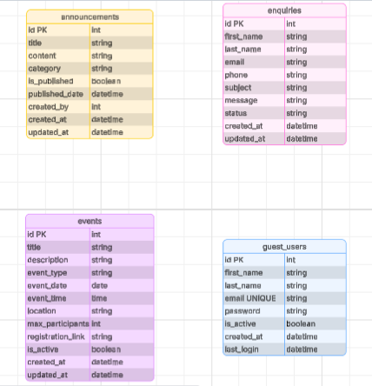

5.3 Table Structures
Complete Database Schema (SQL Script)

Table 1: enquiries

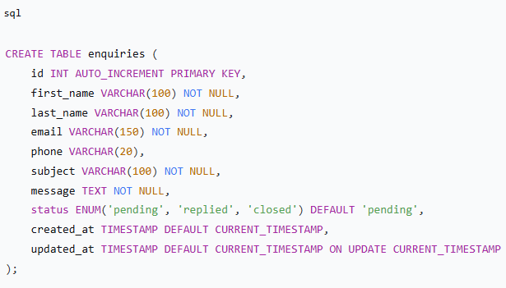

Table 2: guest_users

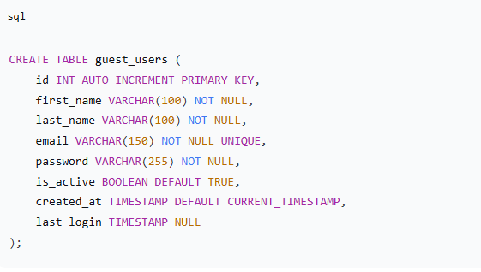

Table 3: events

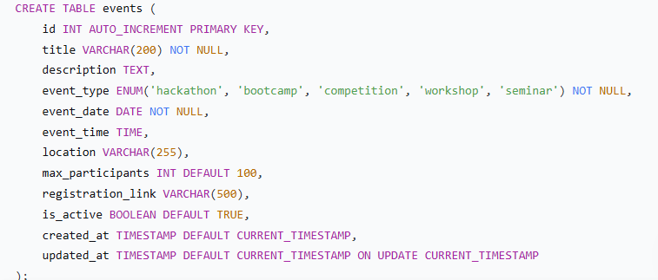

Table 4: announcements
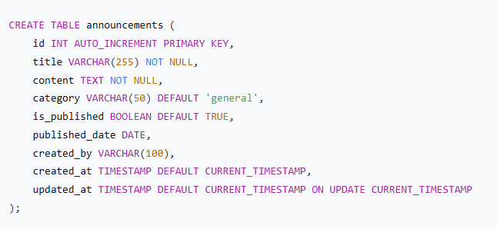

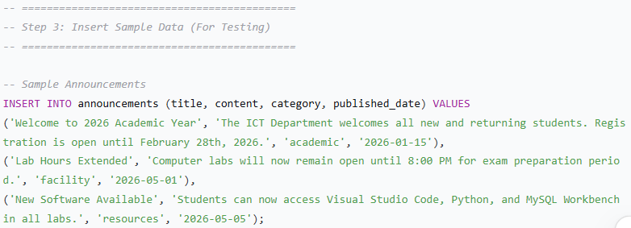

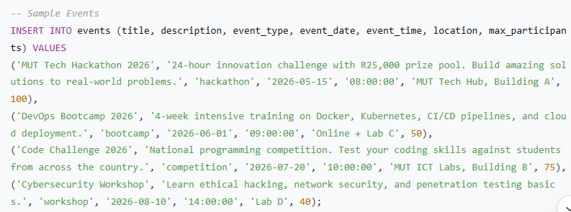

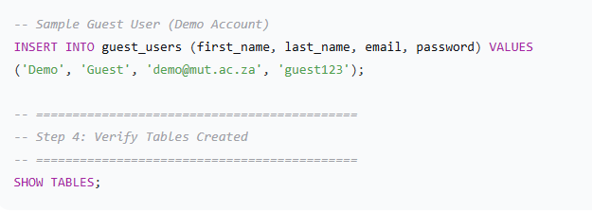

3. Database Setup Instructions
Step 1: Install Prerequisites
Software | Download Link | Purpose
XAMPP (includes MySQL) | apachefriends.org | Local MySQL server
OR MySQL Community Server | mysql.com | Standalone MySQL

Step 2: Start MySQL Service
Using XAMPP:
- Open XAMPP Control Panel
- Click Start next to MySQL
- Verify MySQL is running (green highlight)

Using Command Line (if standalone):
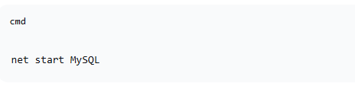
Step 3: Import Database
Method A: Using phpMyAdmin (Recommended)
- Open browser and go to: http://localhost/phpmyadmin
- Click New in left sidebar
- Database name: mut_ict_db
- Click Create
- Click on mut_ict_db in left sidebar
- Click Import tab
- Click Choose File and select mut_ict_db.sql
- Click Go

Method B: Using MySQL Command Line
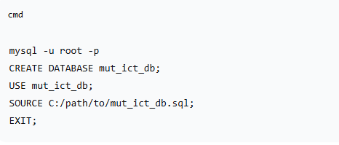
Method C: Using MySQL Workbench
- Open MySQL Workbench
- Connect to your local instance
- Click File → Open SQL Script
- Select mut_ict_db.sql
- Click Execute (lightning bolt icon)

Step 4: Verify Database Setup
Run this query in phpMyAdmin or MySQL Workbench:
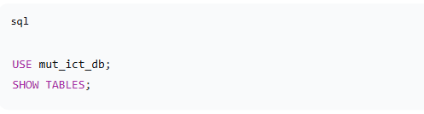

Expected Output:
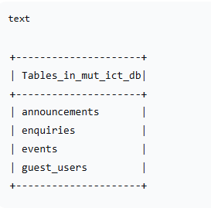
4. Database Connection Configuration
In your server.js file, update these credentials:

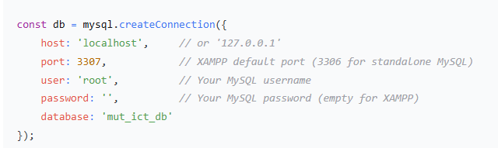

6. Sample Data Overview
Table | Sample Records | Purpose
announcements | 3 | Welcome message, lab hours, software update
events | 4 | Hackathon, Bootcamp, Code Challenge, Workshop
guest_users | 1 | Demo guest account (demo@mut.ac.za / guest123)
enquiries | 0 | Empty - populated when users submit contact form

7. Database File Structure for Submission
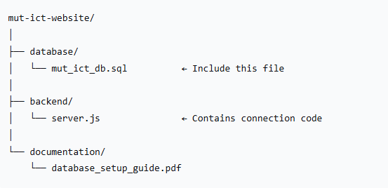

Database Screenshots

5.4 CRUD Operations Implementation
Operation | SQL Query | Endpoint
CREATE | INSERT INTO enquiries ... | POST /api/enquiries
READ | SELECT * FROM enquiries | GET /api/enquiries
UPDATE | UPDATE events SET ... WHERE id = ? | PUT /api/events/:id
DELETE | DELETE FROM enquiries WHERE id = ? | DELETE /api/enquiries/:id

5.5 Database Connection Code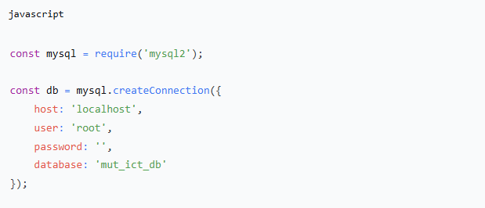

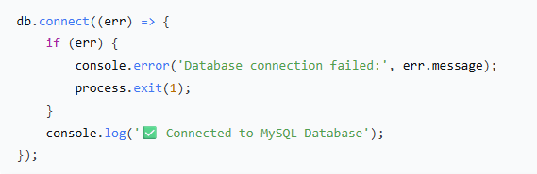

5.6 Sample Data (Pre-populated)
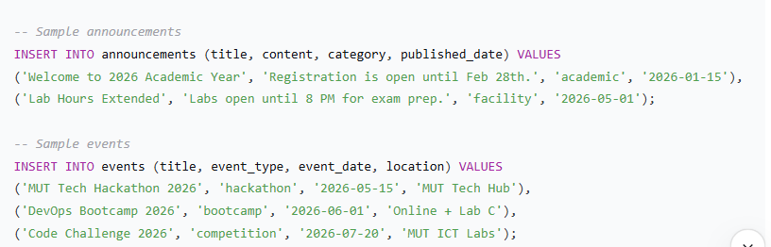

6. MIDDLEWARE IMPLEMENTATION

6.1 Types of Middleware Used
Middleware Type | Purpose | Code
CORS | Allow cross-origin requests | app.use(cors())
JSON Parser | Parse JSON request bodies | app.use(express.json())
URL Encoded | Parse form submissions | app.use(express.urlencoded({ extended: true }))
Custom Logger | Log all requests | See code below
Static Files | Serve notes and assets | app.use('/notes', express.static(...))
404 Handler | Handle unknown routes | app.use('*', (req, res) => {...})

6.2 Custom Logger Middleware
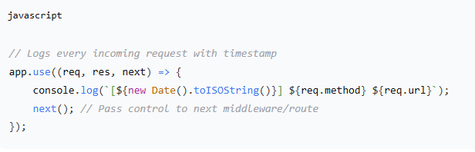

Sample Output:

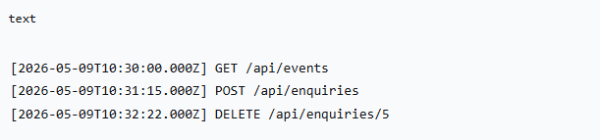

6.3 Why Middleware is Important
Benefit | Explanation
Logging | Tracks all requests for debugging and monitoring
Security | CORS prevents unauthorised domains from accessing APIs
Data Parsing | Automatically converts JSON/form data into JavaScript objects
Error Handling | Catches invalid routes and returns proper 404 responses
Code Organisation | Separates concerns (request processing before business logic)

6.4 Middleware Execution Flow Diagram
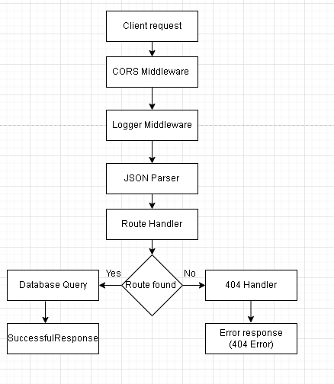
Middleware Execution Flow Diagram Explanation
The Diagram above shows the middleware execution flow within the Express.js backend. Incoming client requests pass through CORS, logging and JSON parsing middleware before reaching the route handler. If a valid route exists, the system performs a database query and returns a successful response. If the route does not exist, the request is redirected to the 404 error handler.

7. AI INTEGRATION & SMART FEATURE

7.1 Smart Feature: MUT ICT AI Assistant (Chatbot)
A fully functional intelligent chatbot is integrated into the website to assist users with queries about the ICT Department.

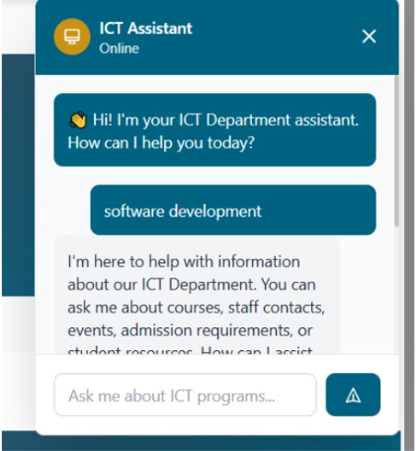
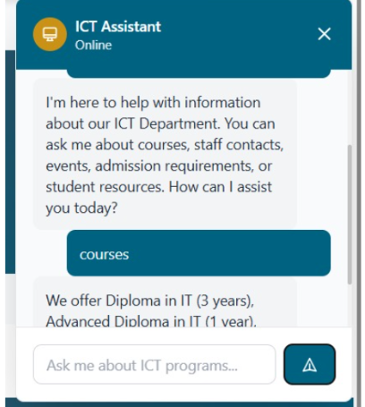
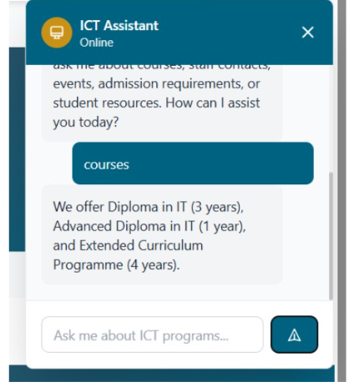

7.2 Chatbot Features
Feature | Description
Natural Language Understanding | Keyword matching to understand user intent
Quick Reply Buttons | Pre-set questions for common topics
Typing Animation | Realistic bot response simulation
Contextual Responses | Detailed answers for programs, admission, staff, resources
Mobile Responsive | Works on all screen sizes

7.3 Knowledge Base Structure
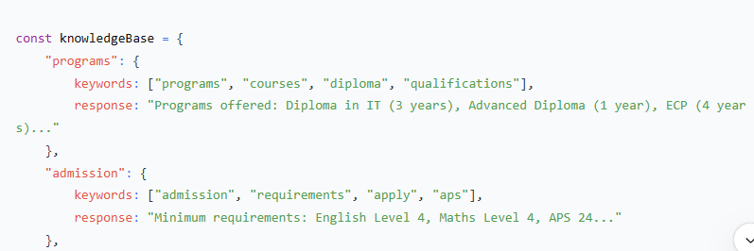
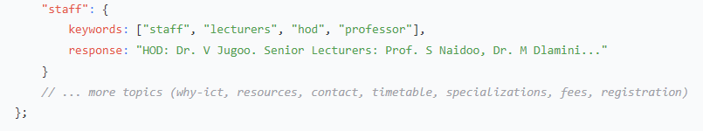

7.4 Chatbot Response Logic
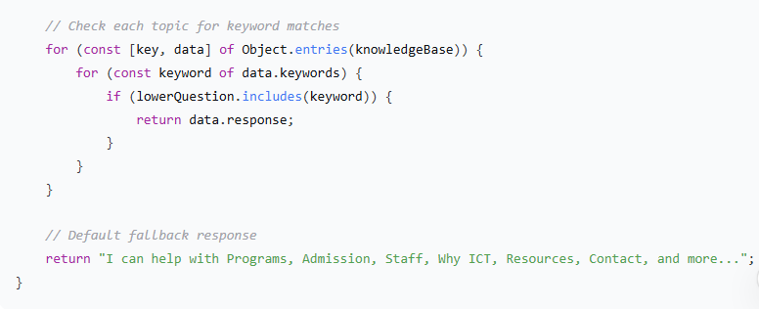
Chatbot Response Logic Diagram
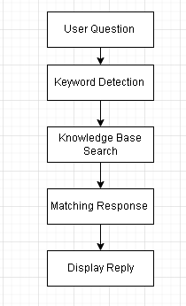
Chatbot Response Logic Diagram Explanation
The diagram above shows the chatbot response process. When a user submits a question, the system detects keywords and searches the knowledge base for matching responses. The most relevant answer is then displayed to the user automatically.

7.5 Chatbot Interface

Component | Description
Floating Button | Bottom-right corner, opens chat window
Chat Header | "MUT ICT Assistant" with close button
Message Area | Scrollable conversation history
Quick Buttons | Programs, Admission, Location, Why ICT
Input Field | Text input with Enter key support
Send Button | Submits user message

7.6 Chatbot User Flow
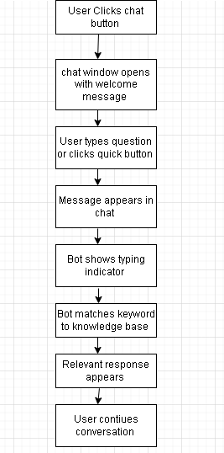
Chatbot User Flow Explanation
The diagram above shows the chatbot user flow within the ICT Department website. Users interact with the chatbot by submitting questions or selecting quick-access buttons. The chatbot processes keywords, searches the knowledge base and returns relevant responses to assist users efficiently.

7.7 Benefits of AI Assistant for ICT Department
Benefit | Impact
24/7 Availability | Students get answers anytime, not just office hours
Reduced Staff Workload | Common questions answered automatically
Instant Responses | No waiting for email replies
Consistent Information | Same accurate answers every time
User Engagement | Interactive element keeps users on site longer

8. FULL SYSTEM INTEGRATION

8.1 System Architecture Diagram
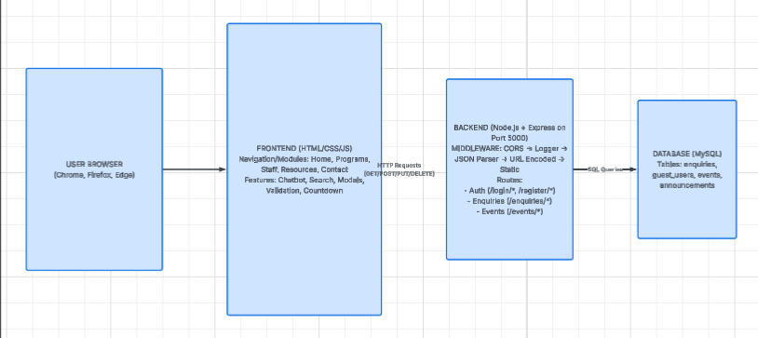
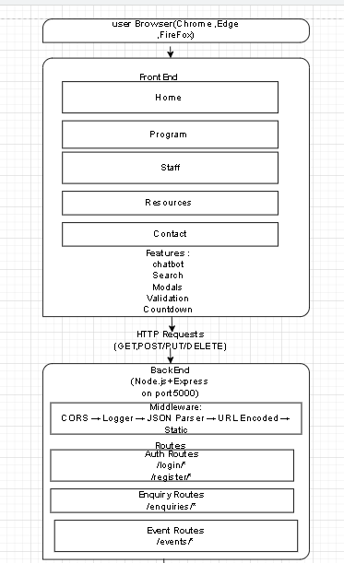
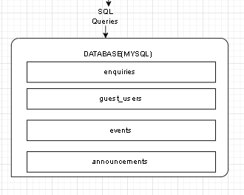
System Architecture Diagram Explanation
The diagram above shows the overall system architecture of the Smart ICT Department Website. Users interact with the frontend interface developed using HTML, CSS and JavaScript. Requests are processed through the Node.js and Express backend using middleware and route handlers before data is stored or retrieved from the MySQL database.

8.2 Data Flow Example: Submitting an Enquiry
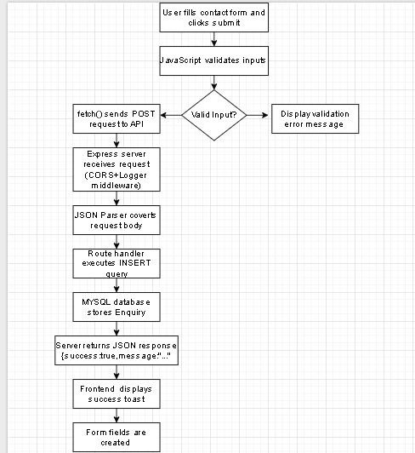
Data Flow Example: Submitting an Enquiry(Diagram Explanation )
The diagram above shows the overall system architecture of the Smart ICT Department Website. Users interact with the frontend interface developed using HTML, CSS and JavaScript. Requests are processed through the Node.js and Express backend using middleware and route handlers before data is stored or retrieved from the MySQL database.

8.3 Testing Summary
Test Case | Expected Result | Status
Login with valid student credentials | Redirect to dashboard | PASS
Login with invalid credentials | Error message displayed | PASS
Submit contact form with validation | Success message + database record | PASS
Search for "programs" | Navigate to Programs page | PASS
Chatbot asks "What programs are offered?" | Returns program information | PASS
Filter programs by Software | Shows only software programs | PASS
Countdown timers | Update every second | PASS
Mobile view (375px) | Hamburger menu, readable text | PASS
GET /api/events | Returns JSON array of events | PASS
POST /api/enquiries | Creates new database record | PASS
DELETE /api/enquiries/:id | Removes record from database | PASS

9. GITHUB REPOSITORY & CODE QUALITY

9.1 Repository Structure
mut-ict-website/
│
├── backend/
│ ├── server.js # Main Express server
│ ├── package.json # Dependencies and scripts
│ ├── package-lock.json # Locked dependency versions
│ └── node_modules/ # (gitignored)
│
├── frontend/
│ ├── index.html # Main website
│ ├── login.html # Authentication page
│ ├── css/
│ │ └── styles.css # Custom styles
│ └── notes/ # Lecture notes and resources
│ ├── Chapter 2 brief content.pdf
│ ├── UXD_Lesson_10.pptx
│ └── ...
│
├── database/
│ └── schema.sql # MySQL database schema
│
├── README.md # Installation instructions
└── .gitignore # Ignored files (node_modules, .env)

9.2 Code Quality Standards
Standard | Implementation
Comments | Inline comments explaining complex logic
Naming Conventions | camelCase for variables, PascalCase for classes
Indentation | Consistent 2-4 spaces
Modularity | Separate concerns (routes, DB, middleware)
Error Handling | Try-catch blocks, proper status codes

9.3 README.md Content
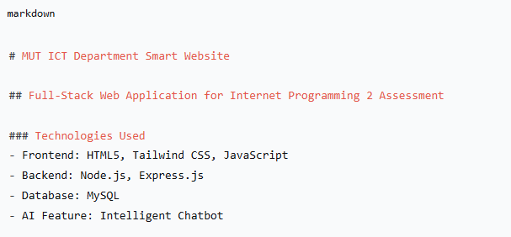
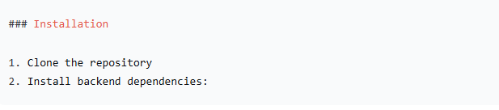
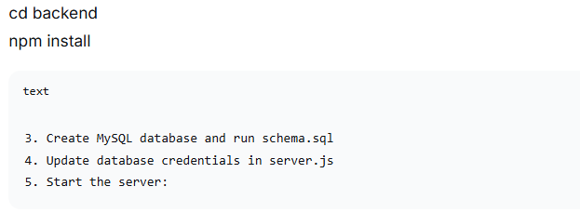
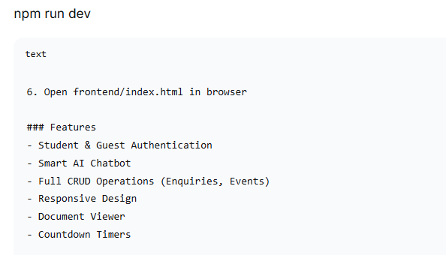
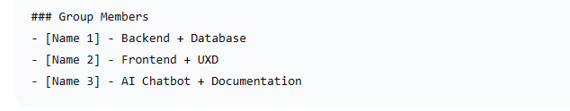

10. GROUP MEMBER CONTRIBUTIONS
Member Name | Student Number | Contribution
RHONGWANA B & GUMBI MP | 22422182  22330742 | Backend development, database design, API routes, MySQL integration
CEBEKHULU KS | 22322695 | Frontend development, HTML/CSS structure, responsive design, UXD analysis
MNYAWE S | 22425322 | AI chatbot implementation, documentation, testing, presentation
NGCOBO AM | 22433852 | JavaScript interactivity, modals, search functionality, form validation

Evidence of Technical Contribution (All Members)
Member | Code Files Contributed
RHONGWANA B | server.js, database schema, API endpoints
MNYAWE S | index.html, styles.css, page layouts, navigation
CEBEKHULI KS & NGCOBO AM | Chatbot JavaScript, documentation, README
GUMBI MP | Form validation, modal JS, countdown timers, search

11. INSTALLATION & RUNNING INSTRUCTIONS

Prerequisites
Software | Version | Purpose
Node.js | v18+ | Run backend server
MySQL | v8+ | Database
XAMPP/WAMP | Latest | Local MySQL server
Browser | Chrome/Firefox | View frontend

Step-by-Step Setup

Step 1: Start MySQL
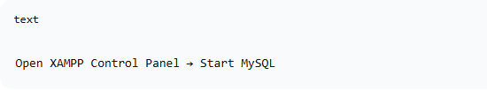

Step 2: Create Database
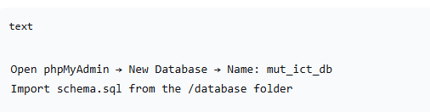

Step 3: Install Backend Dependencies
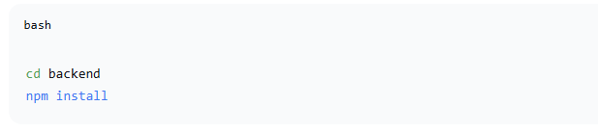

Step 4: Update Database Credentials
In server.j, update:
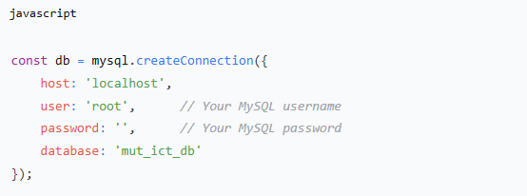

Step 5: Start Backend Server
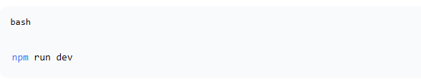
Expected output:
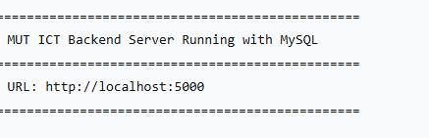

Step 6: Open Frontend
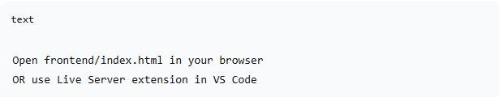

Step 7: Login (Demo Credentials)
Role | Username | Password
Student | 202412345 | student123
Student | 202412346 | student456
Guest | Register new | Create your own

